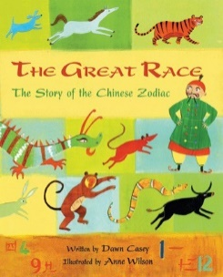
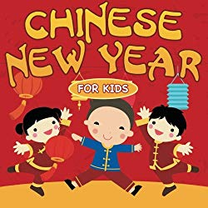
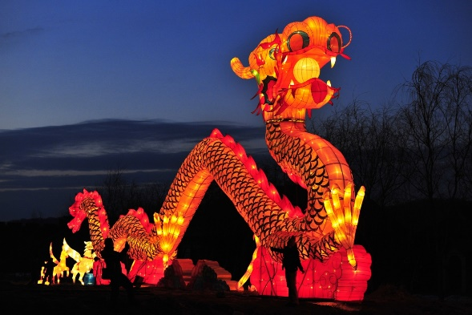
VOCABULARY
festival celebration lantern
chopsticks fortune cookie
race dancing dragon
China flag money wallet
moon firework Emperor

c

7 FACTS ABOUT CHINESE NEW YEAR
- Chinese New Year is a festival to celebrate the start of a new year.
- There is a lantern festival on the last day of the Chinese New Year.
- Red is a lucky colour.
- The Chinese flag is red with 5 stars on.
- Every year is named after a different animal. These animals are: rat, ox, tiger, rabbt, dragon, snake, horse, goat, monket, rooster, dog and pig.
- The rat won the great race and was named after the first year.
- Chinese New Year is linked to the new moon.

Stories linked to Chinese New Year
Useful Websites
https://www.topmarks.co.uk/ChineseNewYear/ChineseNewYear.aspx

Chinese New Year
Chinese New Year is a festival to celebrate the start of a new year.

